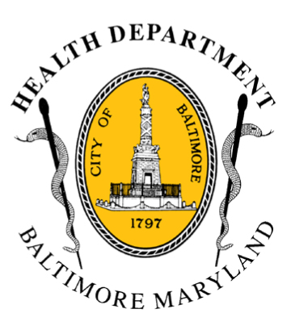
BCHD PRESS RELEASE
Baltimore City Health Department
1001 E. Fayette Street • Baltimore, Maryland 21202
Stephanie Rawlings-Blake, Mayor
Leana Wen, M.D., Commissioner of Health

FOR IMMEDIATE RELEASE
Media Contact: Michael Schwartzberg, PIO
O: (443) 984-2623 C: (443) 462-7939 E: michael.schwartzberg@baltimorecity.gov
Wellmobile Parked In Penn-North Community
To Assist Residents As Recovery Continues

BALTIMORE, MD (May 6, 2015) – The University of Maryland Baltimore School of Nursing Governor’s Wellmobile will be parked at the corner of North Avenue and Fulton Avenue in the city’s Penn-North community today through Friday May 8th from 11am to 5pm each day. The Wellmobile will be staffed by volunteers from the University of Maryland Baltimore as well as staff from the Mayor’s Office of Neighborhoods and the Baltimore City Health Department.

“Many residents are still trying to meet basic needs such as food and medication access,” said Baltimore City Health Commissioner Dr. Leana Wen. “Bringing this resource into the community allows citizens to directly obtain information as our city rebuilds and heals.”

Wellmobile staff can assist residents with a variety of needs, such as:

- Obtaining prescription medication
- Receiving up-to-date pharmacy availability information
- Navigating 311 to obtain needed services
- Finding out when and where food distributions will take place
- Locating donation distribution centers
- Learning about available transportation services for residents
- Coordinating other services as needed.

In addition, with the assistance of the Maryland Department of Aging, BCHD has launched a free shuttle service that will operate Monday – Friday during the month of May. The shuttle will have two daily trips (pickups at 930 am & 1:30 pm at 10 different residential buildings, depending on the day of the week) taking residents to a Super WalMart and a Giant supermarket, helping ensure that they have access to food and other needs. The schedule can be found on our website, http://health.baltimorecity.gov/.

Residents can find up-to-date information on a variety of health related services at the Health Department’s website and by following BCHD on social media - Facebook (www.facebook.com/BaltimoreHealth) and Twitter (https://twitter.com/BMore_Healthy), as well as by following the hashtags #HealBaltimore and #OneBaltimore.

###

